

**FPT ACADEMY INTERNATIONAL**

**FPT – APTECH COMPUTER EDUCATION**

**USER GUIDE FOR CARBREEZY WEBSITE**

1. **Shop Cars**

- This webpage allows users to find the information for the products they’re looking for. To get the details of a particular item, users need to click on image or text, which will automatically open the information page for that item. For example, figure 3 illustrates how to get detailed information for single product.

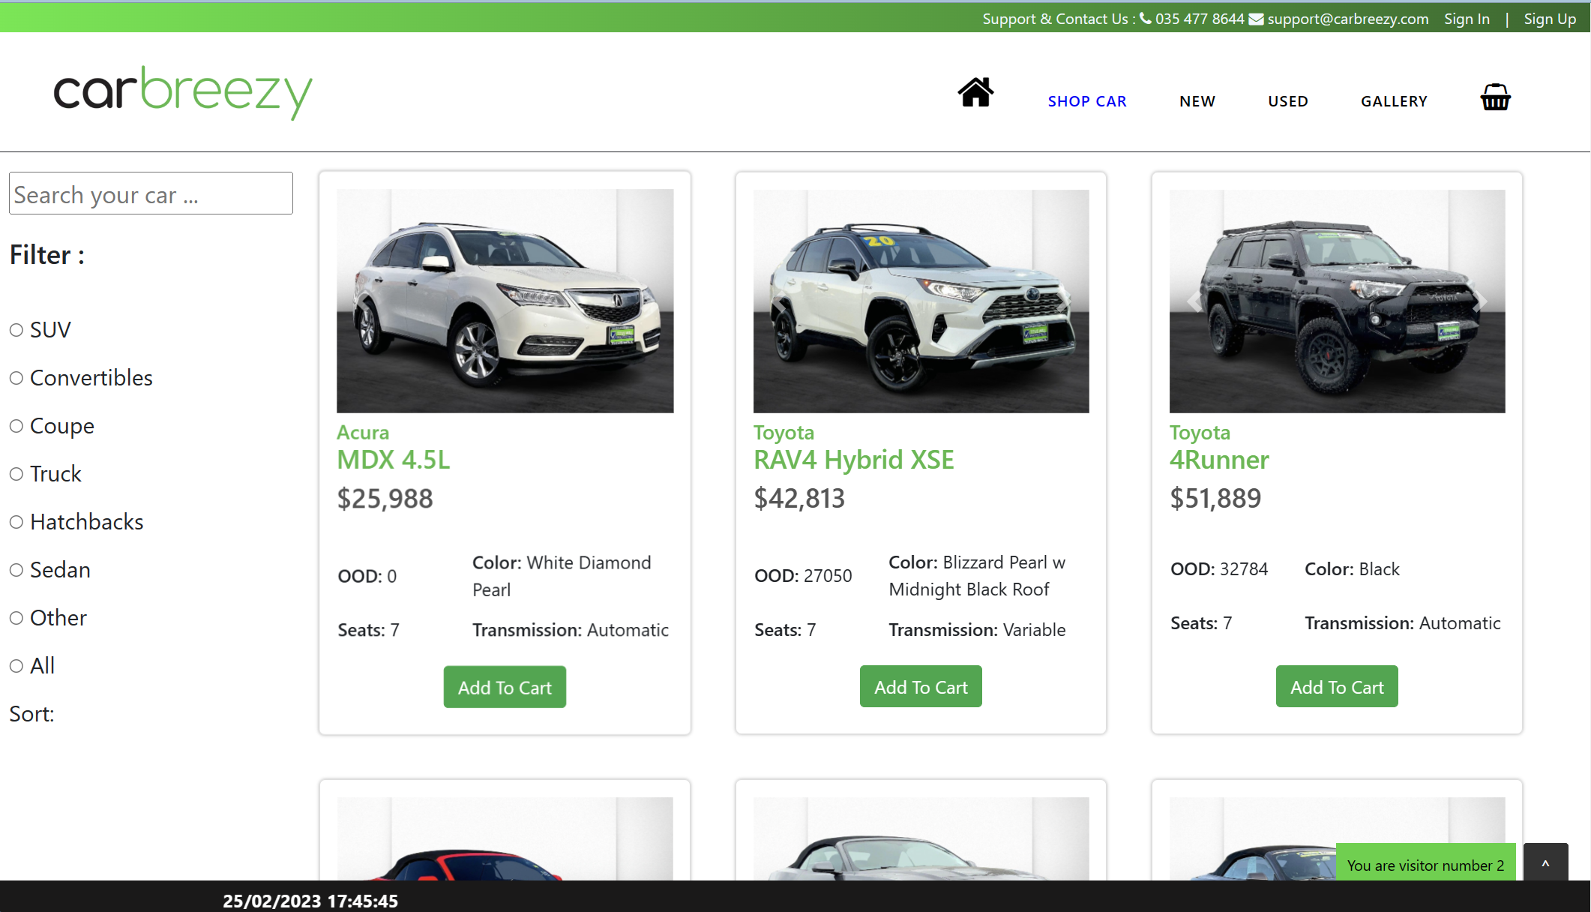

*Figure 1*

- To make it easier for users to find the product as fast as possible, we created to filter option and search bar.

+ As for search bar: To use this function, users need to type the name of a particular product and then press enter. To reset, they need to erase what they typed and press enter.

1. **New Cars**

- Take a look at our amazing collection of New cars!

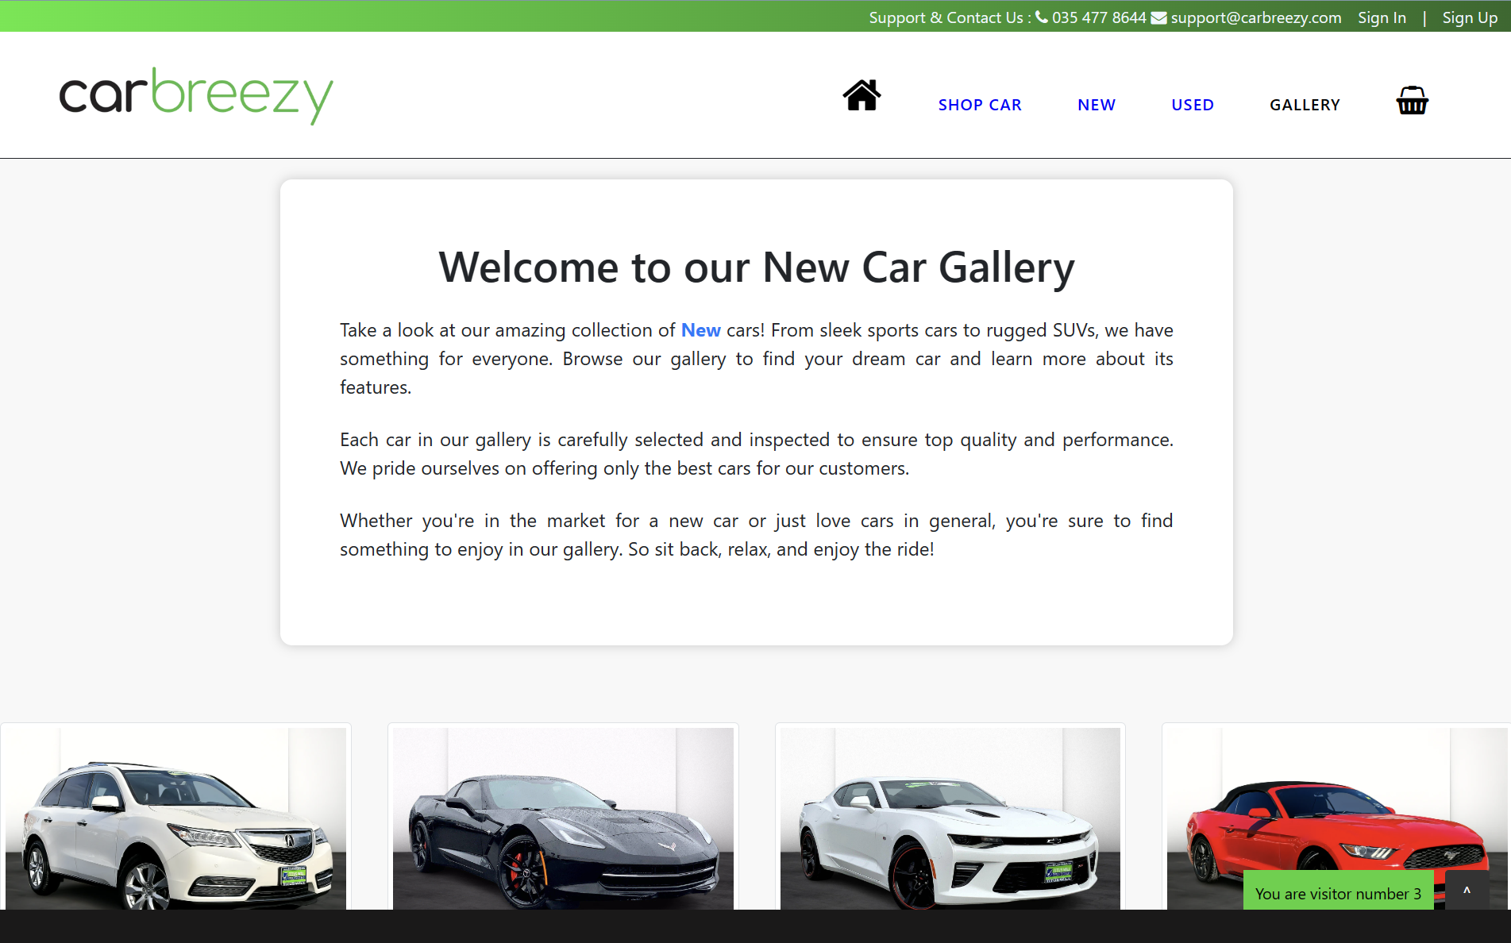

*Figure 2*

1. **Old Cars**

In addition to providing you with a great selection of Used cars, we also offer financing options to help you get behind the wheel of your dream car.

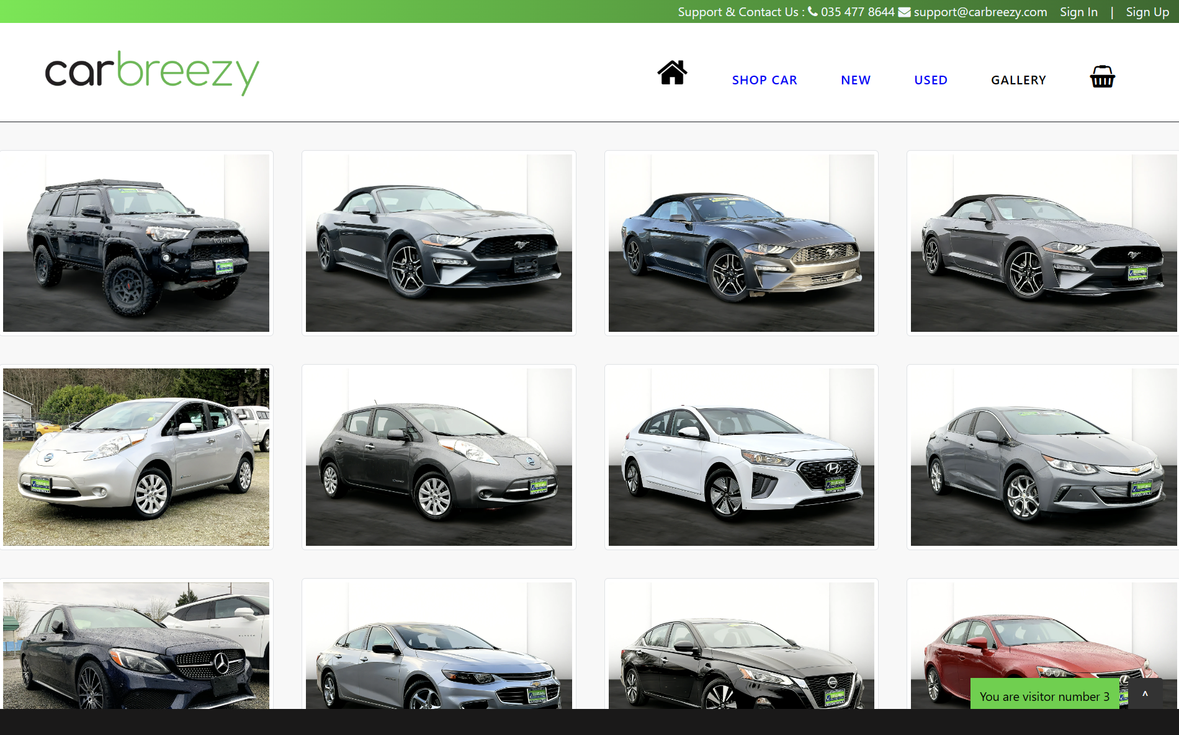

*Figure 3*

1. **Gallary**

- This page displays gallery collection of cars.

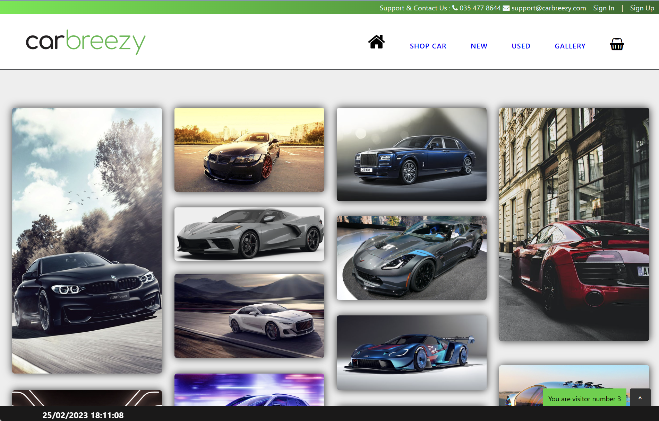

*Figure 4*

1. **About Us**

- This page displays information about Carbreezy team and our team member.

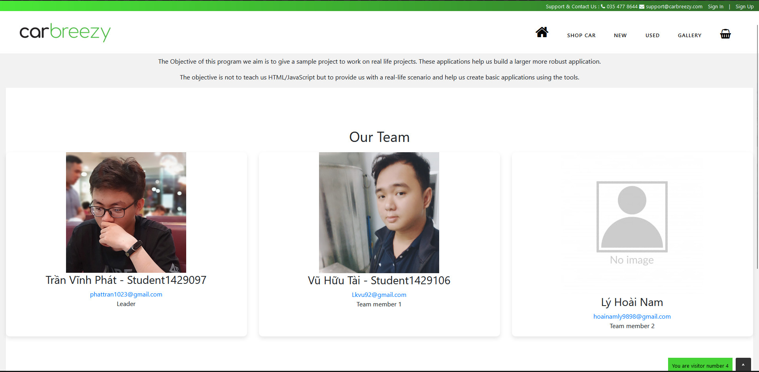

*Figure 5*